Eclipse To Soap

Following Jars to be added in Java Build Path 🡪 Libraries

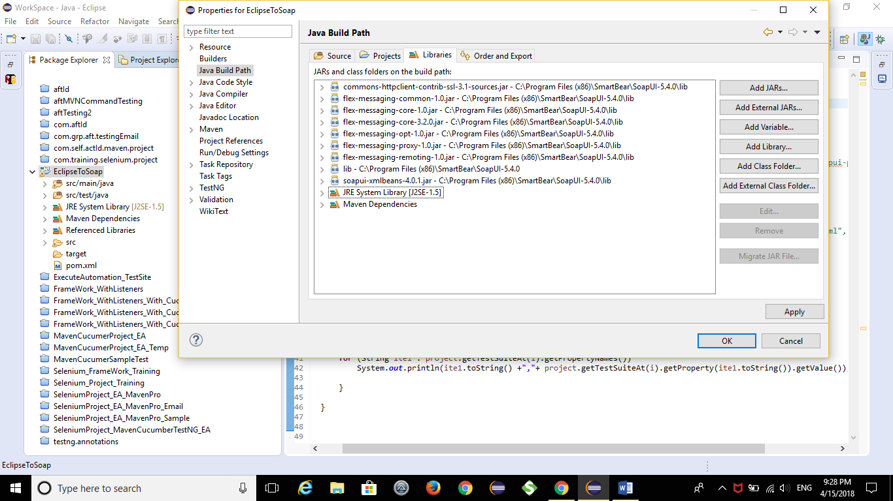

Pom.xml 🡪 Entries in pom.xml file is show below

*********************************************************************************

<project xmlns=*"http://maven.apache.org/POM/4.0.0"* xmlns:xsi=*"http://www.w3.org/2001/XMLSchema-instance"*

xsi:schemaLocation=*"http://maven.apache.org/POM/4.0.0 http://maven.apache.org/xsd/maven-4.0.0.xsd"*>

<modelVersion>4.0.0</modelVersion>

<groupId>com.raja.eclipsetosoap</groupId>

<artifactId>EclipseToSoap</artifactId>

<version>0.0.1-SNAPSHOT</version>

<packaging>jar</packaging>

<name>EclipseToSoap</name>

<url>http://maven.apache.org</url>

<properties>

<project.build.sourceEncoding>UTF-8</project.build.sourceEncoding>

</properties>

<build>

<plugins>

<plugin>

<groupId>org.apache.maven.plugins</groupId>

<artifactId>maven-enforcer-plugin</artifactId>

<version>1.4.1</version>

<configuration>

<rules><dependencyConvergence/></rules>

</configuration>

</plugin>

</plugins>

</build>

<dependencies>

<dependency>

<groupId>junit</groupId>

<artifactId>junit</artifactId>

<version>3.8.1</version>

<scope>test</scope>

</dependency>

<!-- https://mvnrepository.com/artifact/com.github.redfish4ktc.soapui/soapui -->

<dependency>

<groupId>com.github.redfish4ktc.soapui</groupId>

<artifactId>soapui</artifactId>

<version>4.0.1.0</version>

</dependency>

<!-- https://mvnrepository.com/artifact/org.apache.xmlbeans/xmlbeans -->

<dependency>

<groupId>org.apache.xmlbeans</groupId>

<artifactId>xmlbeans</artifactId>

<version>2.6.0</version>

</dependency>

<!-- https://mvnrepository.com/artifact/log4j/log4j -->

<dependency>

<groupId>log4j</groupId>

<artifactId>log4j</artifactId>

<version>1.2.17</version>

</dependency>

<!-- https://mvnrepository.com/artifact/commons-httpclient/commons-httpclient -->

<dependency>

<groupId>commons-httpclient</groupId>

<artifactId>commons-httpclient</artifactId>

<version>3.1</version>

</dependency>

<!-- https://mvnrepository.com/artifact/commons-cli/commons-cli -->

<dependency>

<groupId>commons-cli</groupId>

<artifactId>commons-cli</artifactId>

<version>1.1</version>

</dependency>

<dependency>

<groupId>xalan</groupId>

<artifactId>serializer</artifactId>

<version>2.7.1</version>

</dependency>

<!-- https://mvnrepository.com/artifact/xerces/xercesImpl -->

<dependency>

<groupId>xerces</groupId>

<artifactId>xercesImpl</artifactId>

<version>2.8.0</version>

</dependency>

<!-- https://mvnrepository.com/artifact/org.bouncycastle/bcprov-jdk16 -->

<dependency>

<groupId>org.bouncycastle</groupId>

<artifactId>bcprov-jdk16</artifactId>

<version>1.45</version>

</dependency>

<dependency>

<groupId>wsdl4j</groupId>

<artifactId>wsdl4j</artifactId>

<version>1.6.2</version>

</dependency>

<!-- https://mvnrepository.com/artifact/org.codehaus.groovy/groovy-all -->

<dependency>

<groupId>org.codehaus.groovy</groupId>

<artifactId>groovy-all</artifactId>

<version>3.0.0-alpha-1</version>

</dependency>

</dependencies>

</project>

*********************************************************************************

Main Function in Java Class :

**package** com.raja.eclipsetosoap.EclipseToSoap;

**import** java.io.IOException;

**import** org.apache.xmlbeans.XmlException;

**import** com.eviware.soapui.impl.wsdl.WsdlProject;

**import** com.eviware.soapui.support.SoapUIException;

**public** **class** CallSoapProject {

**public** **static** **void** main(String args[]) **throws** XmlException, IOException, SoapUIException

{

// Loading Soap Project

WsdlProject project = **new** WsdlProject ("D:/Soap_Project/Calculator-soapui-project.xml");

System.***out***.println(project.getTestSuiteCount());

// Get Test Suite Count and Print all test Suite names

**for**(**int** i=0;i<project.getTestSuiteCount();i++)

{

System.***out***.println(project.getTestSuiteAt(i).getName());

// Get all properties from each test suite and print

**for** (String ite1 : project.getTestSuiteAt(i).getPropertyNames())

System.***out***.println(ite1.toString() +","+ project.getTestSuiteAt(i).getProperty(ite1.toString()).getValue());

}

}

}